**DATABASE MANAGEMENT SYSTEM**

**LAB-3**

**DDL COMMANDS**

**NAME: VISHWAS M**

**SRN : PES2UG20CS390**

**SEC : F**

**DATE : 04/09/2022**

Create tables for the Above-mentioned Relational design and add check, default, not null and unique constraints.

1)PK and FK constraints for all applicable Relations

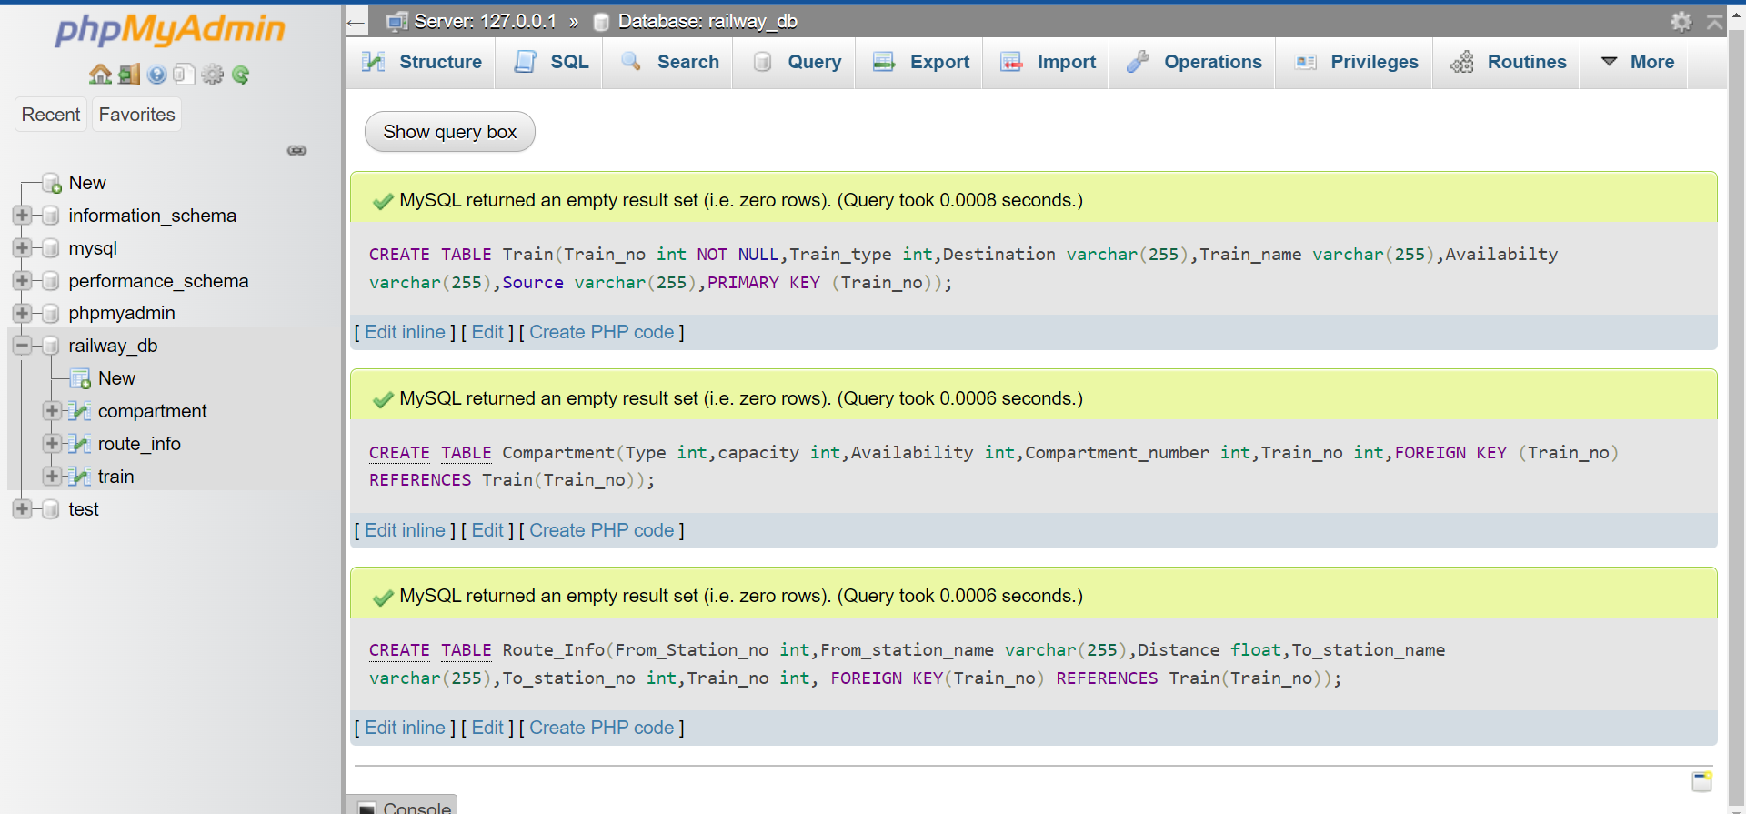i)

ii)

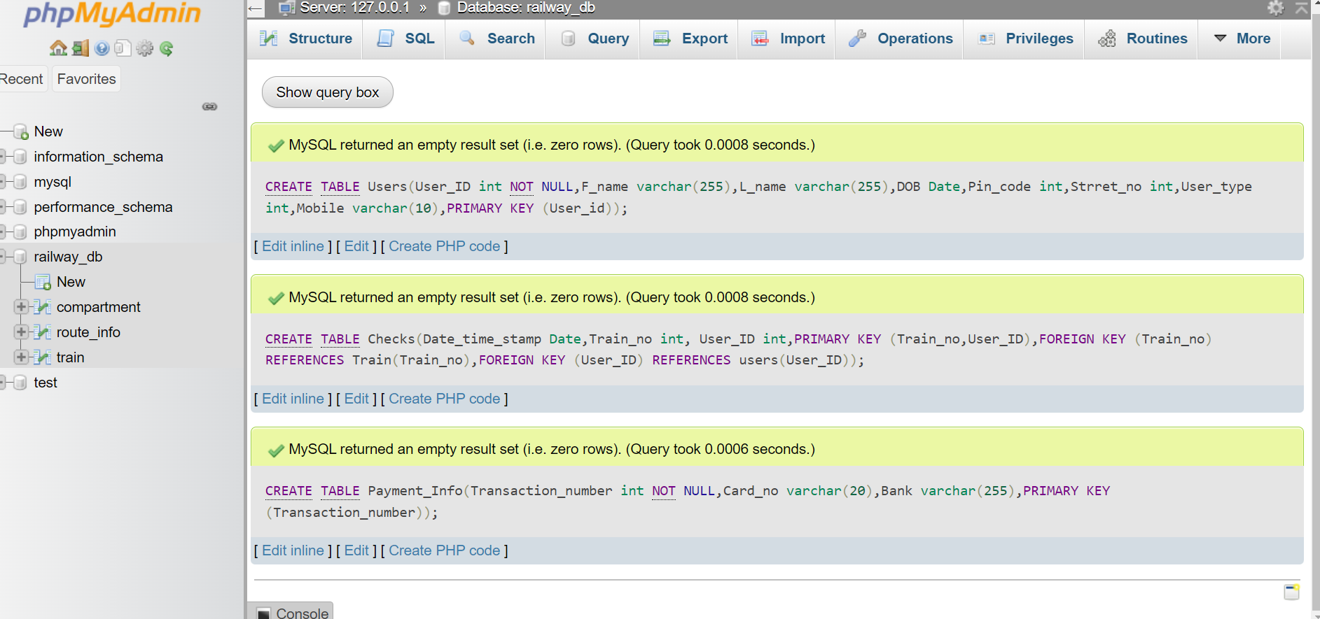

iii)

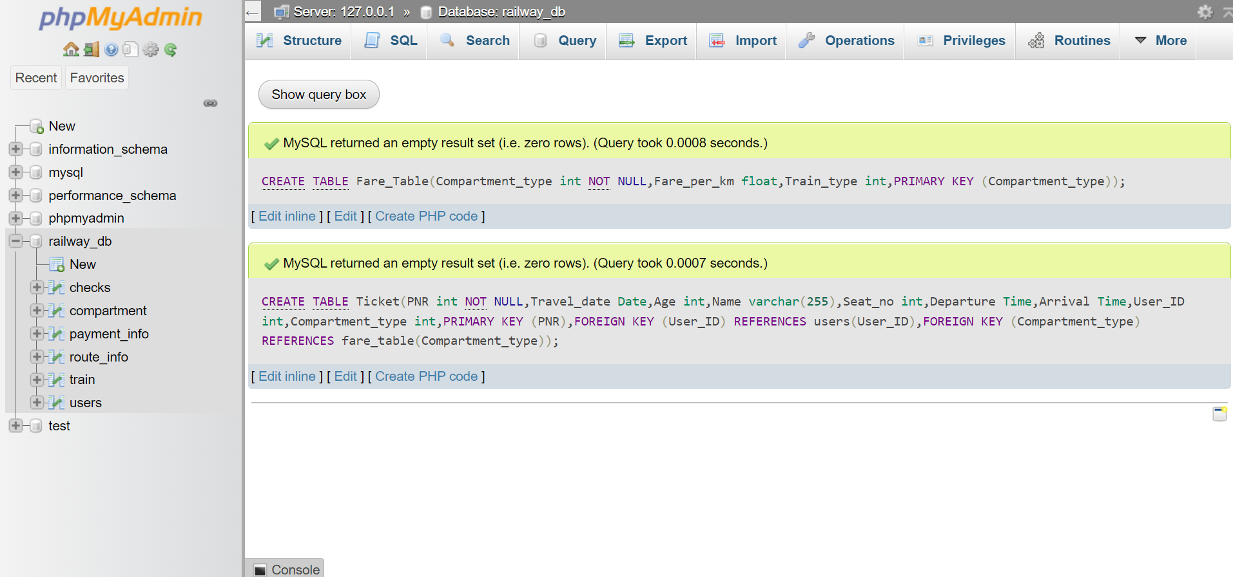

2)For Train_name, Train_Type in Train table add not null constraints value

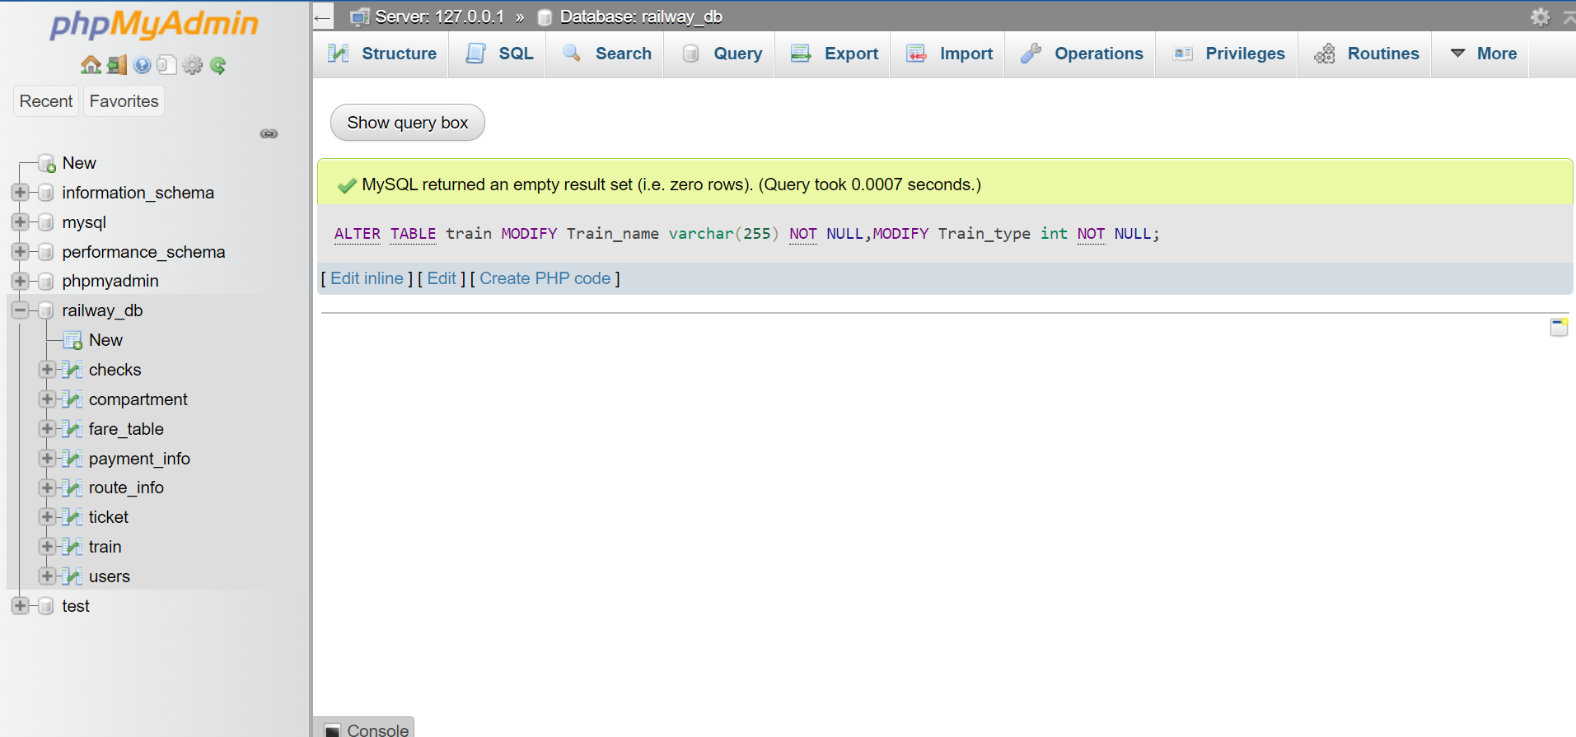

3) Add defaultconstraint for compartment table setting Availability attribute to Yes

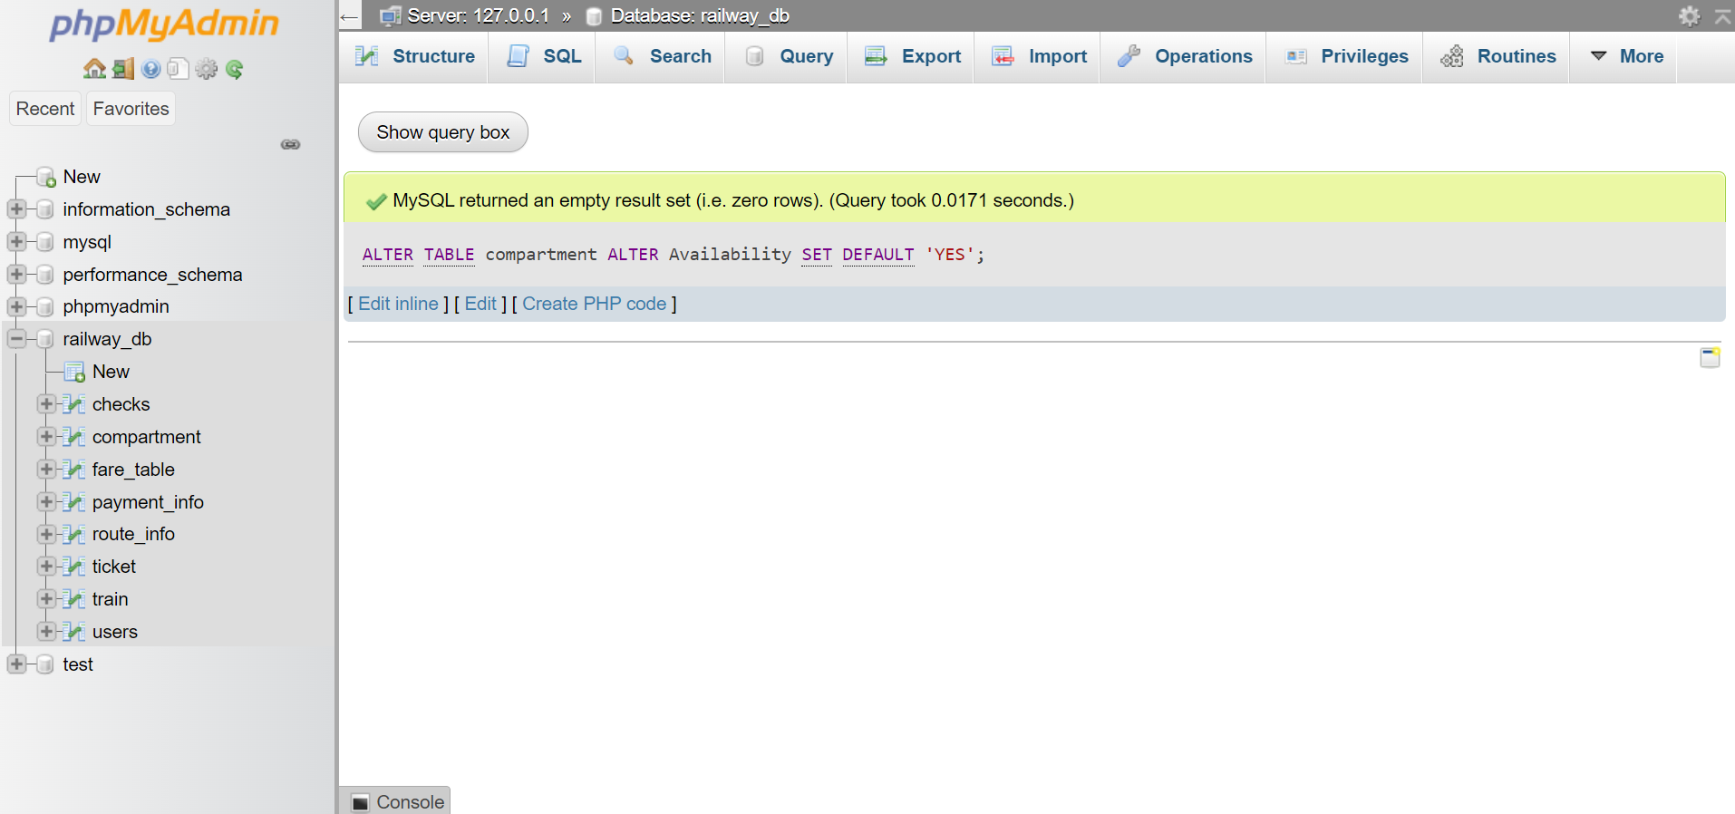

4)PNR should be unique

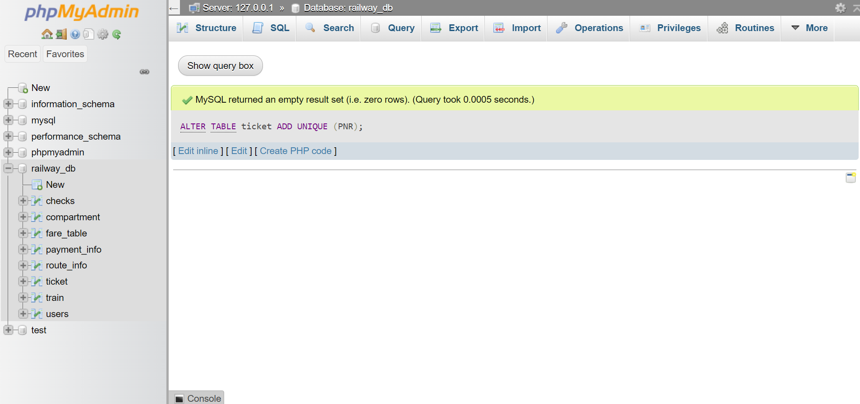

5)Add check constraints to Age in the invoice (Age>5)

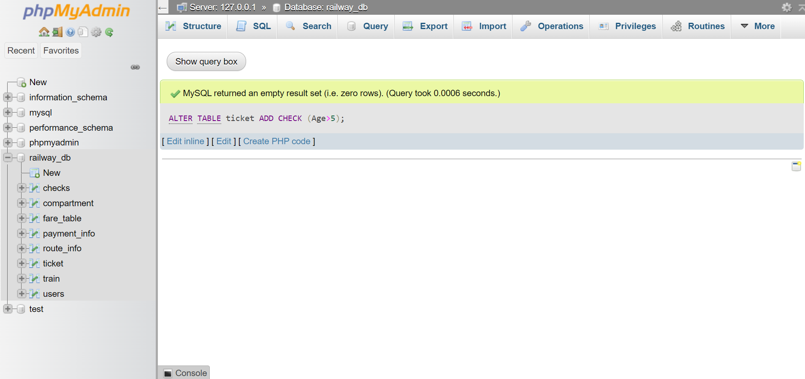

6)Rename the table

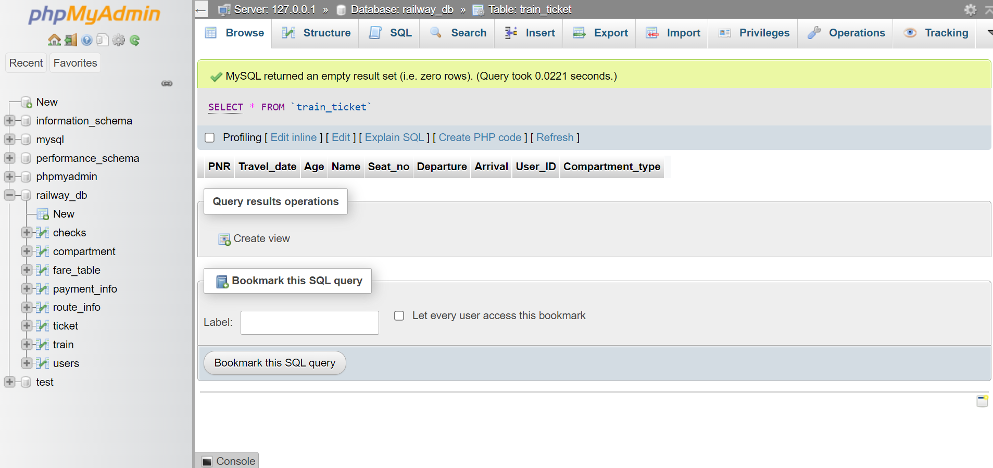

7)Create a view using create view command

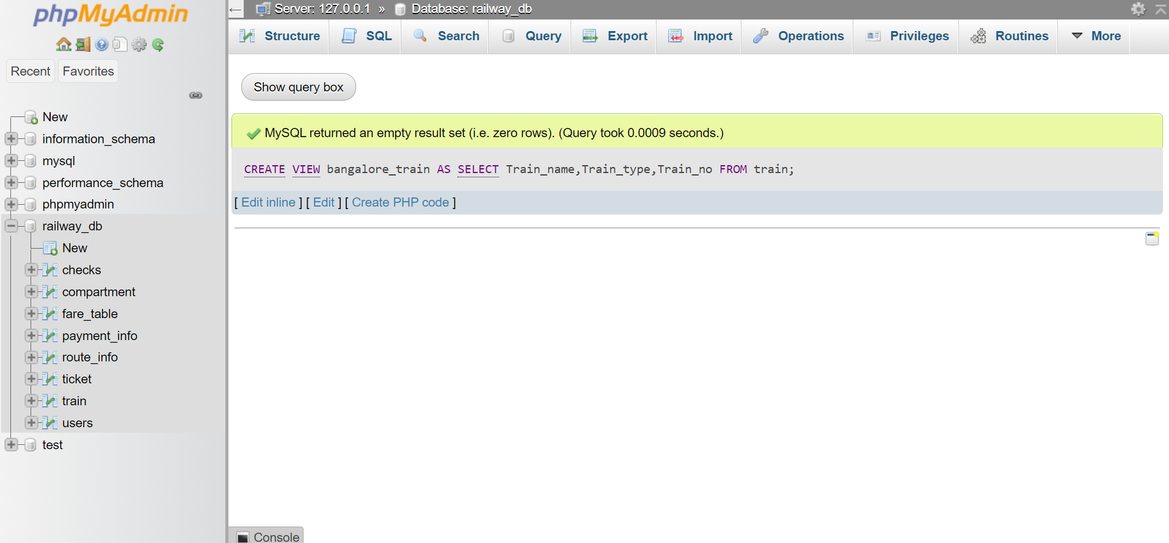

8) use drop commands

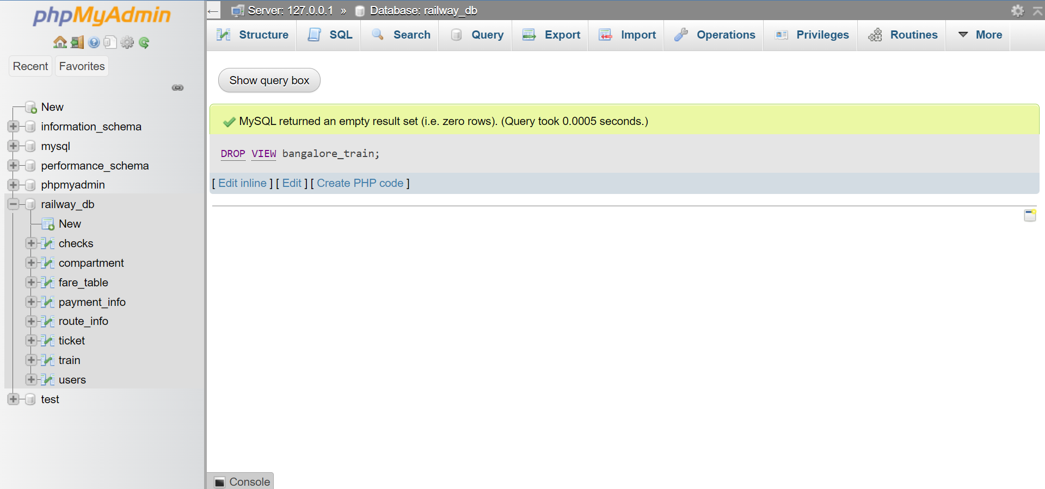

**OVERALL DATABASE:**

